***ONLINE NEWS PORTAL***

***ABIONA DAPHNE.P(1631002)***

***MONIKA.M.G(1631029)***

***R.P.SHRI SWEATHA(1631050)***

***ABSTRACT:***

*The purpose of Online news portal is to automate the existing manual system by the help of computerized equipments and full-fledged computer software,fulfilling their requirements ,so that their valuable data can be stored for a longer period with easy accessing and manipulation of the same.*

*Online news portal allows customers to read up to dat news related to many fields like entertainment,national,international,business,sports etc without any payment or login.*

*He can also contact us to give suggestion and can also give us feedback related to our site.*

*New news can be added only by the admin and only admin have the right to update or delete any news.Admin have the right to give authority to other for news update,add or delete.The traditional media rooms all around the world are fast adapting to the new age technologies.This marks the beginning of news portal by media houses across the globe.This new media channels give them the opportunity to reach the viewers in a shorter span of time than their print media counterparts.*

**ADVANTAGES:**

*\*News on the Internet can be updated round the clock so that readers can have the most up to date news anytime of the day or night.*

*\*Once a news item is put on the internet,it becomes instantly available for use round the globe without additional variable costs.*

*\*The type of news and the way it is presented can be customized to the needs and preferences of individual readers.*

***DATABASE DESIGN****:*

*The general theme behind a database is to handle information as an integrated whole.*

*A database is a collection of interrelated data stored with minimum redundancy to serve many users quickly and effectively.After designing input and output, the analyst must concentrate on database design or how data should be organized around user requirements.The general objective is to make information access,easy quick,inexpensive anf flexible for other users.*

*During database design the following objectives are concerned:*

*\*Controled redundancy*

*\*Data independence*

*\*Accurate and integrating*

*\*Performance*

***REQUIREMENTS:***

* *System needs to store information about new entry of news.*
* *Keep record of all the breaking news.*
* *Need to update or delete the record.*
* *Needs a search area.*

***SOFTWARE REQUIREMENTS:***

* *Web server*
* *JSP*
* *MYSQL*

***Functionalities:***

***HOMEPAGE CUSTOMISATION:***

*Instant breaking news updates with unfolding stories of popular interest.*

*Frequent content update of the news portal.*

*The* ***search bar*** *allows the readers to pick the topics or contents of their choice.*

***ADMIN :***

*On logging in, the person has options to:*

*1.News and Category Report.*

*2.Edit profile information.*

*3.Add news Or Category.*

*4.System User Report.*

*5.Forgot password.*

*6.Logout.*

***NEWS DETAILS:***

*The news details page consist of complete information of the news and* ***comments*** *section.*

*Admin has the authority to upload news in the Database.*

*User can give comments and those comments will be saved in the comment description table.*

*There are different* ***news category*** *like sports,entaintainment,share market etc…*

*Admin can add or delete any of the category.*

*Editing,adding and updating of records is improved which results in proper management of news data.*

***FORM DESIGN:***

***NEWS DETAILS PAGE:***

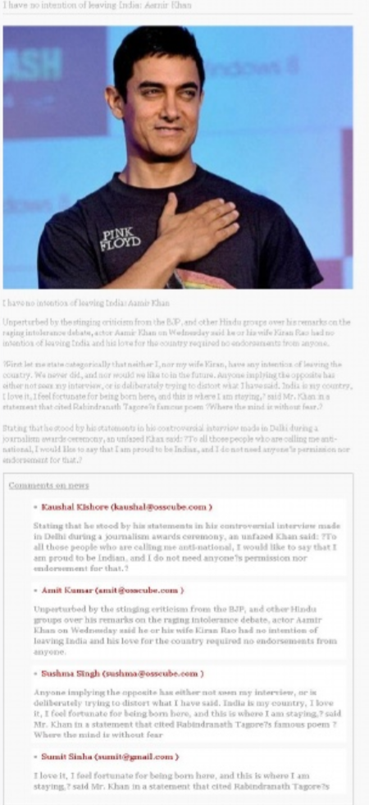

***NAME***

***EMAIL ID***

***COMMENTS***

***ADMIN DASHBOARD SCREEN:***



***NEWS AND CATEGORY REPORT***

***ADD SYSTEM USER***

***ADD NEWS OR CATEGORY***

***CHANGE PASSWORD***

***LOGOUT***

***ADMIN LOGIN:***

***LOGIN***

***USERNAME:***

***PASSWORD:***

***CHANGE PASSWORD:***

***CHANGE PASSWORD***

***OLD PASSWORD:***

***NEW PASSWORD: ***

***CONFIRM : ***

***RESET PASSWORD***

***ADD SYSTEM USER:***

***REGISTRATION FORM***

***LAST NAME***

***MIDDLE NAME***

***FIRST NAME***

***NATIONALITY***

***DATE OF BIRTH***

***GENDER***

***MOBILE***

***EMAIL***

***ADDRESS***

***EMPLOYEE ROLE***

***PASSWORD***

***USERNAME***

***RESET FORM***

***SAVE FORM***

***REPORTS OF ONLINE NEWS PORTAL:***

* *It generates report on News,News category and Latest News.*
* *Provides filter on Sports,Entertainment etc..*
* *Easily export PDF for the news and latest news.*

***ONLINE NEWS PORTAL***

*ALL ABOUT THE NEWS.*

**

**